**3rd Assignment: Social Contagion - Graph Analytics**

For this assignment we implemented an algorithm that simulates the dynamic of a spreading phenomena with a given threshold (0.015) for contagion in our real graph about the football players from the serie A that played together during the same period in the same team. This algorithm starts from a random node in the graph, and infects all the neighbors from the infected ones that have more than 1 in 66 infected neighbors in each iteration. As our graph has an average degree of approx. 150, the threshold allows the contagion to spread slowly at the beginning but completely in about 9 iterations:

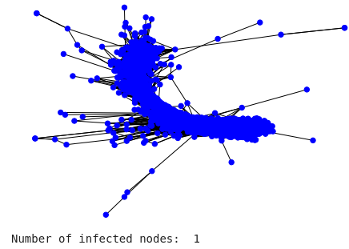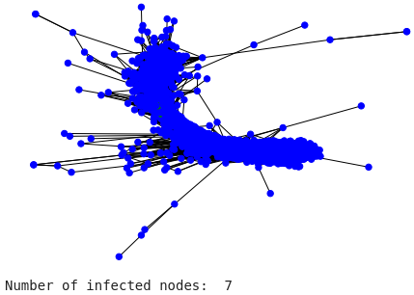

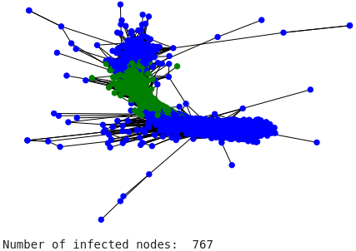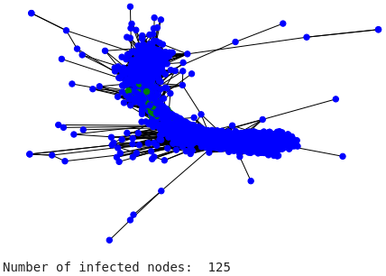

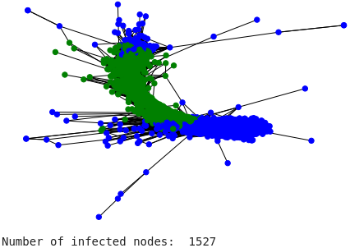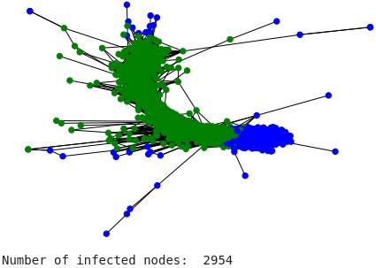

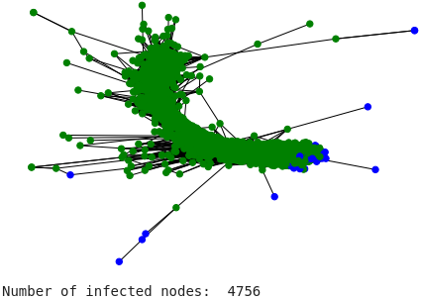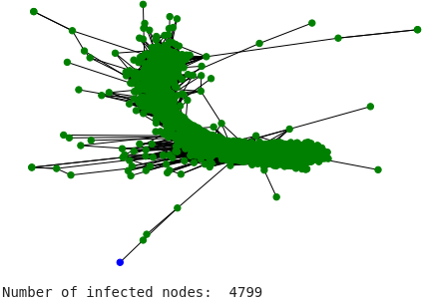

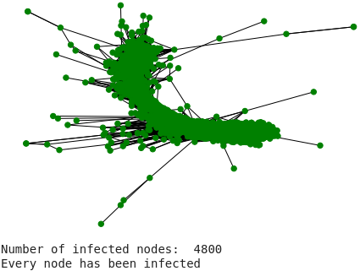

**Comparing the spreading phenomena between different initial nodes**

After testing this algorithm we decided to experiment changing the initial node from where the contagion should spread. In this case, the node with most betweenness, the node with most closeness and the node with most degree were selected:

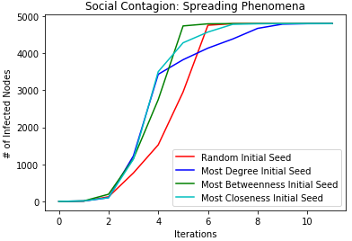

As we can see, it takes more iterations for the node with most degree the spread the contagion but the time that it takes to raise the number of infections considerably is really fast, same as the one with most closeness. So in this case, even though the first to completely infect every node in the network is the one with most betweenness, it has more priority to stop the one that raises the number of infected more quickly. At least for containing the contagion in this kind network we should be more careful of the nodes with most degree and most closeness.